1. Donot put a terminator at the end of a macro declaration as it will lead to the generation of an error
eg: #define pi 3.14; This is wrong statement and the use of the terminator should be avoided in this case.

2. %p is the format specifier for the pointer variables.

3. %04x is the format specifier for hexadecimal numbers.

4. To use the functions of math.h in a c program. we have to type the following command to compile the source code :
gcc -o output -lm input.c
This is used to link the math library with the executable file.

5. The pre or post increment/decrement give the same execution in a for loop because the flow of control in a loop is like:
-> Check the condition.
-> Execute the statements.
-> increment/decrement.

6. Difference between type function(void) and type function() is such that the former cannot be called by passing
argument through it unlike the latter.

7. \n and \t are called escape sequences.
Escape Meaning
\\ Literal backslash
\" Double quote
\' Single quote
\n Newline (line feed)
\r Carriage return
\b Backspace
\t Horizontal tab
\f Form feed
\a Alert (bell)
\v Vertical tab
\? Question mark (used to escape trigraphs)
\nnn Character with octal value nnn
\xhh Character with hexadecimal value hh

8. A null character is represented by '\0'.

9. system("clear") for linux and system("cls") for windows is a function that clears the console screen and is the part of the
stlib.h library.

10. Wide character strings
C supports wide character strings, defined as arrays of the type wchar_t, 16-bit (at least) values. They are written with an L before the string like this

wchar_t *p = L"Hello world!";
This feature allows strings where more than 256 different possible characters are needed (although also variable length
char strings can be used). They end with a zero-valued wchar_t. These strings are not supported by the <string.h> functions.
Instead they have their own functions, declared in <wchar.h>.
The basic functions are wprintf() and wscanf().

11. #include <stdio.h>
#include <string.h>
#include <math.h>
#include <stdlib.h>

int main()
{ char ch, s[20],sen[20];
ch = getchar();
scanf("%s",&s);
scanf(" %[^\n]%*c",&sen);
printf("%c\n%s\n%s",ch,s,sen);

/* Enter your code here. Read input from STDIN. Print output to STDOUT */
return 0;
}

12. The function atoi() in C converts a string to an integer.

13. To input a value in an iterable statement always use scanf(" %format_specifier"). The space before the format specifier
tells the compiler to ignore any newline entry(The enter keystroke that can cause problems in the code).
for example::

When you enter a character and hit enter, character gets accepted by getchar() and when the loop starts again
\n is accepted because of the enter key you have given in the previous iteration,
so.... Everytime you enter a character and hit enter... two inputs are taken and thus, this behaviour is observed.
To overcome this, use

scanf(" %c",&grade);
Note : Here a space is given in front of %c to omit empty spaces

Instead of:

grade=getchar()
In the loop.

14. kbhit() function returns a non zero value when a key is pressed and a non zero value when no key is pressed.
It is a function of the conio.h header file.

15. A static int variable is always implicitly initialised as 0.

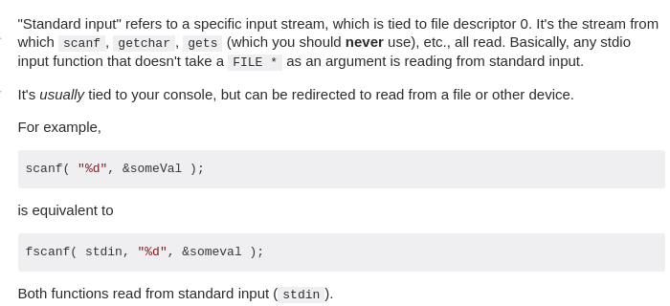
16.

17. Registers are faster than memory to access, so the variables which are most frequently used in a C program can be put in registers using register keyword. The keyword register hints to compiler that a given variable can be put in a register. It's compiler's choice to put it in a register or not.

